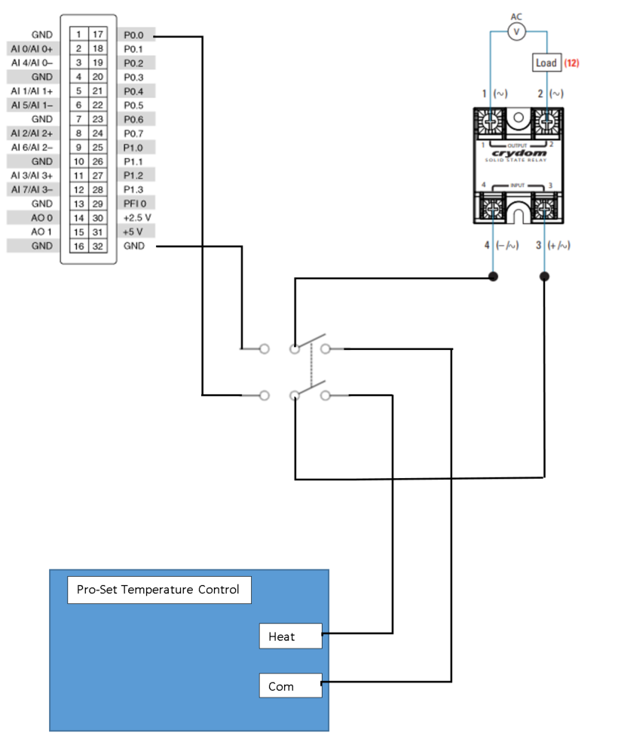Blue M Wiring Diagram

**Note:**

Over Temperature Protection will still operate normally.

Double Pole Double Throw Switch

* Down Position: Pro-Set Temperature Control
* Up Position: NI USB 6009

Solid State Relay

NI USB 6009